Private First Class Forrest Rice
HQ Company, 2nd Battalion, 16th Infantry Regiment, 1st Infantry Division
Omaha Beach

Draft Registration Card
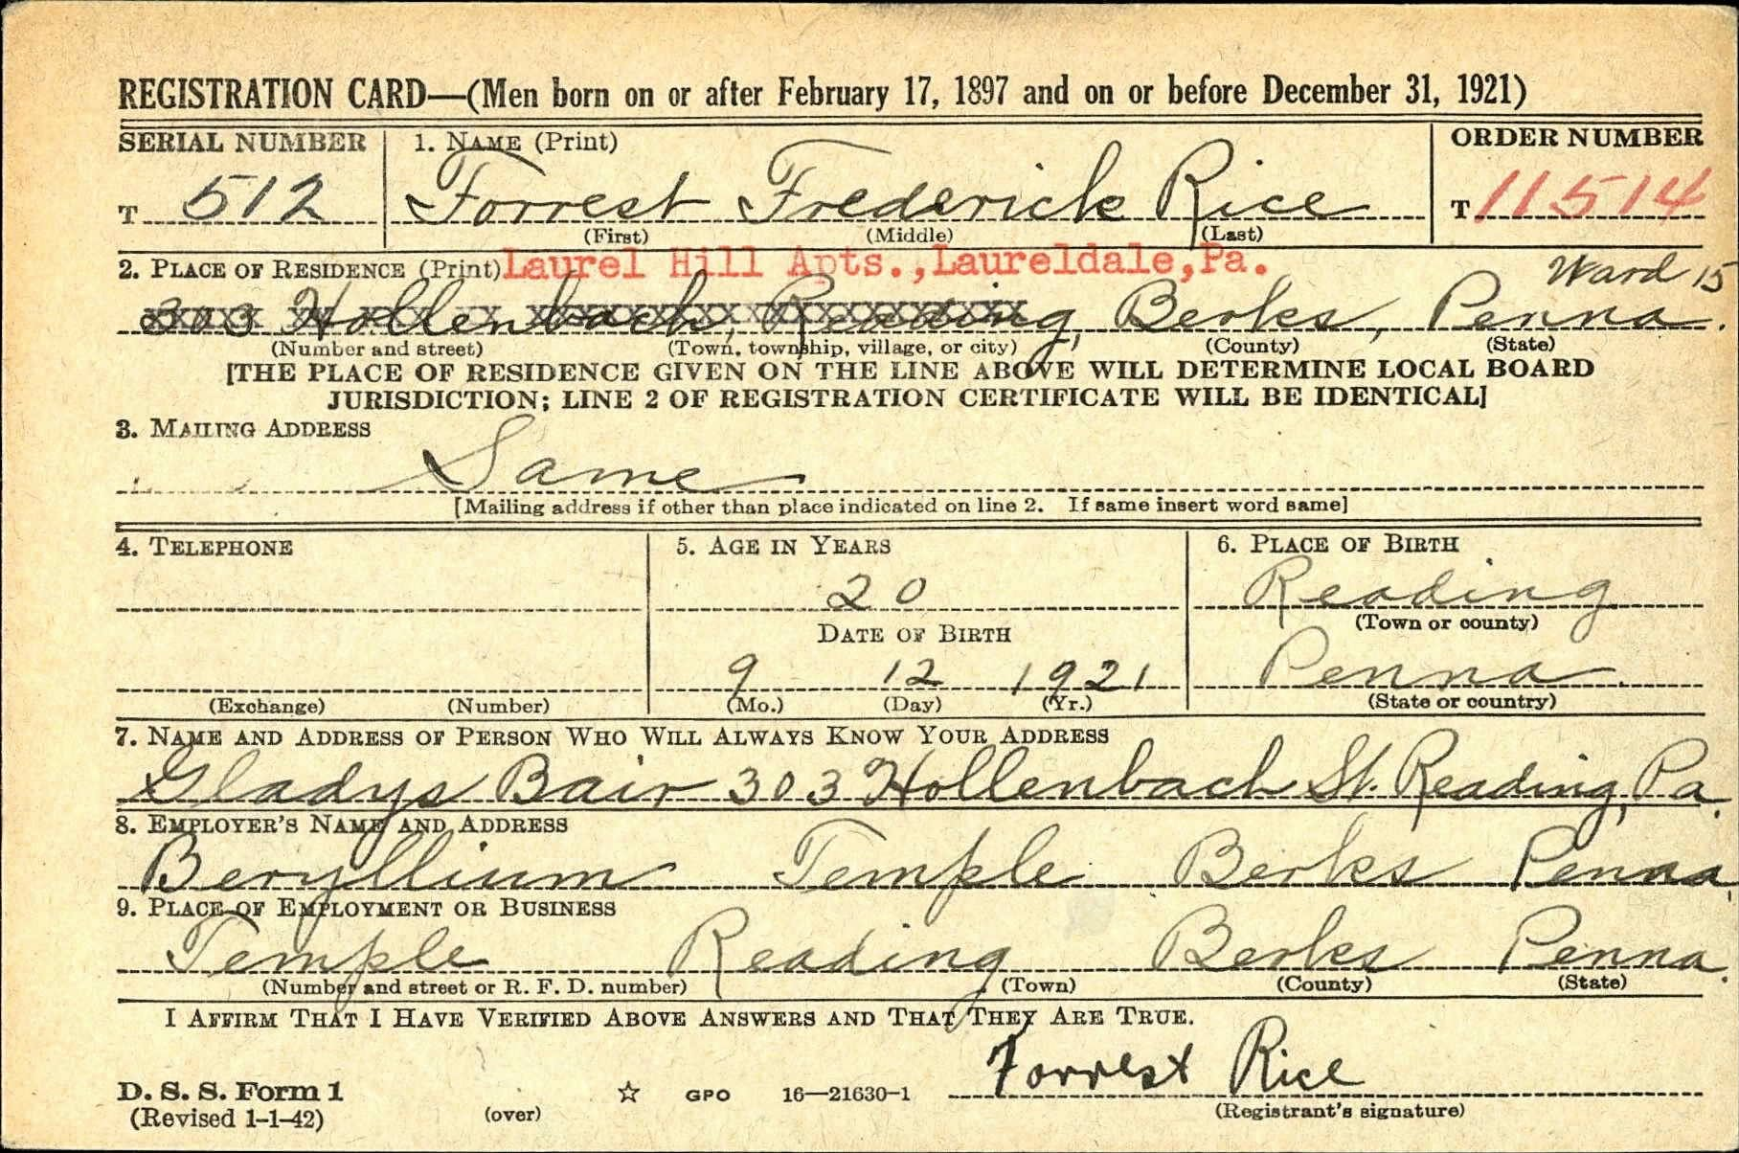

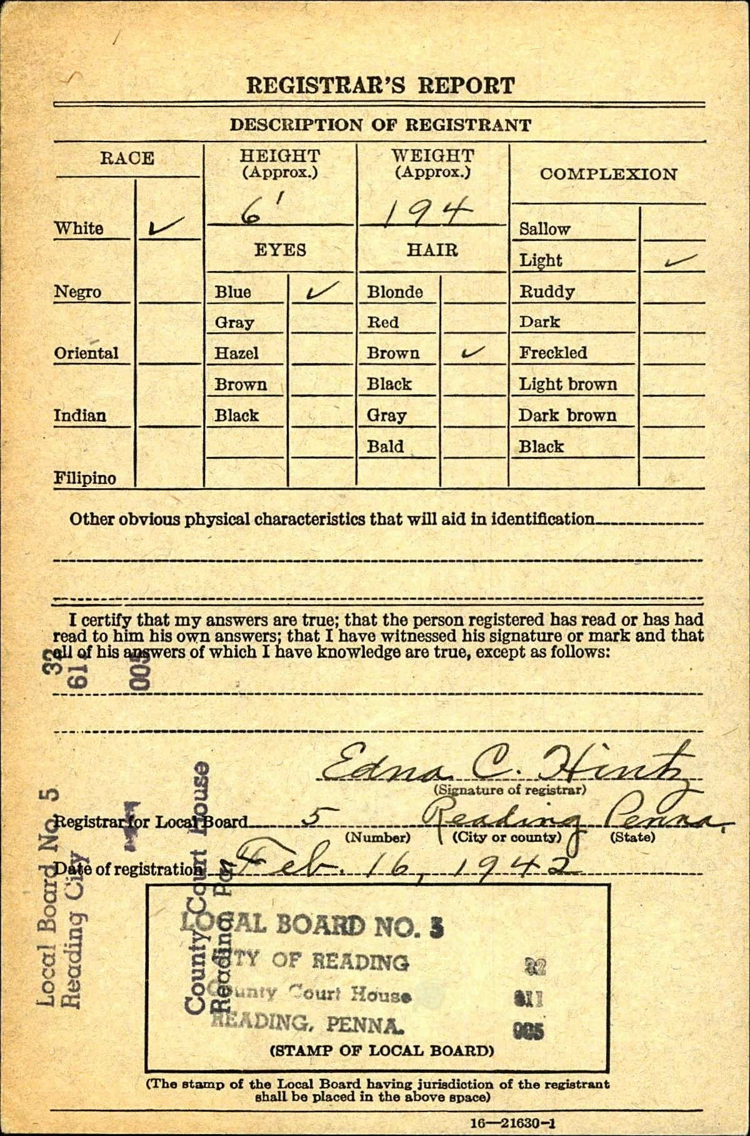
Pension Application
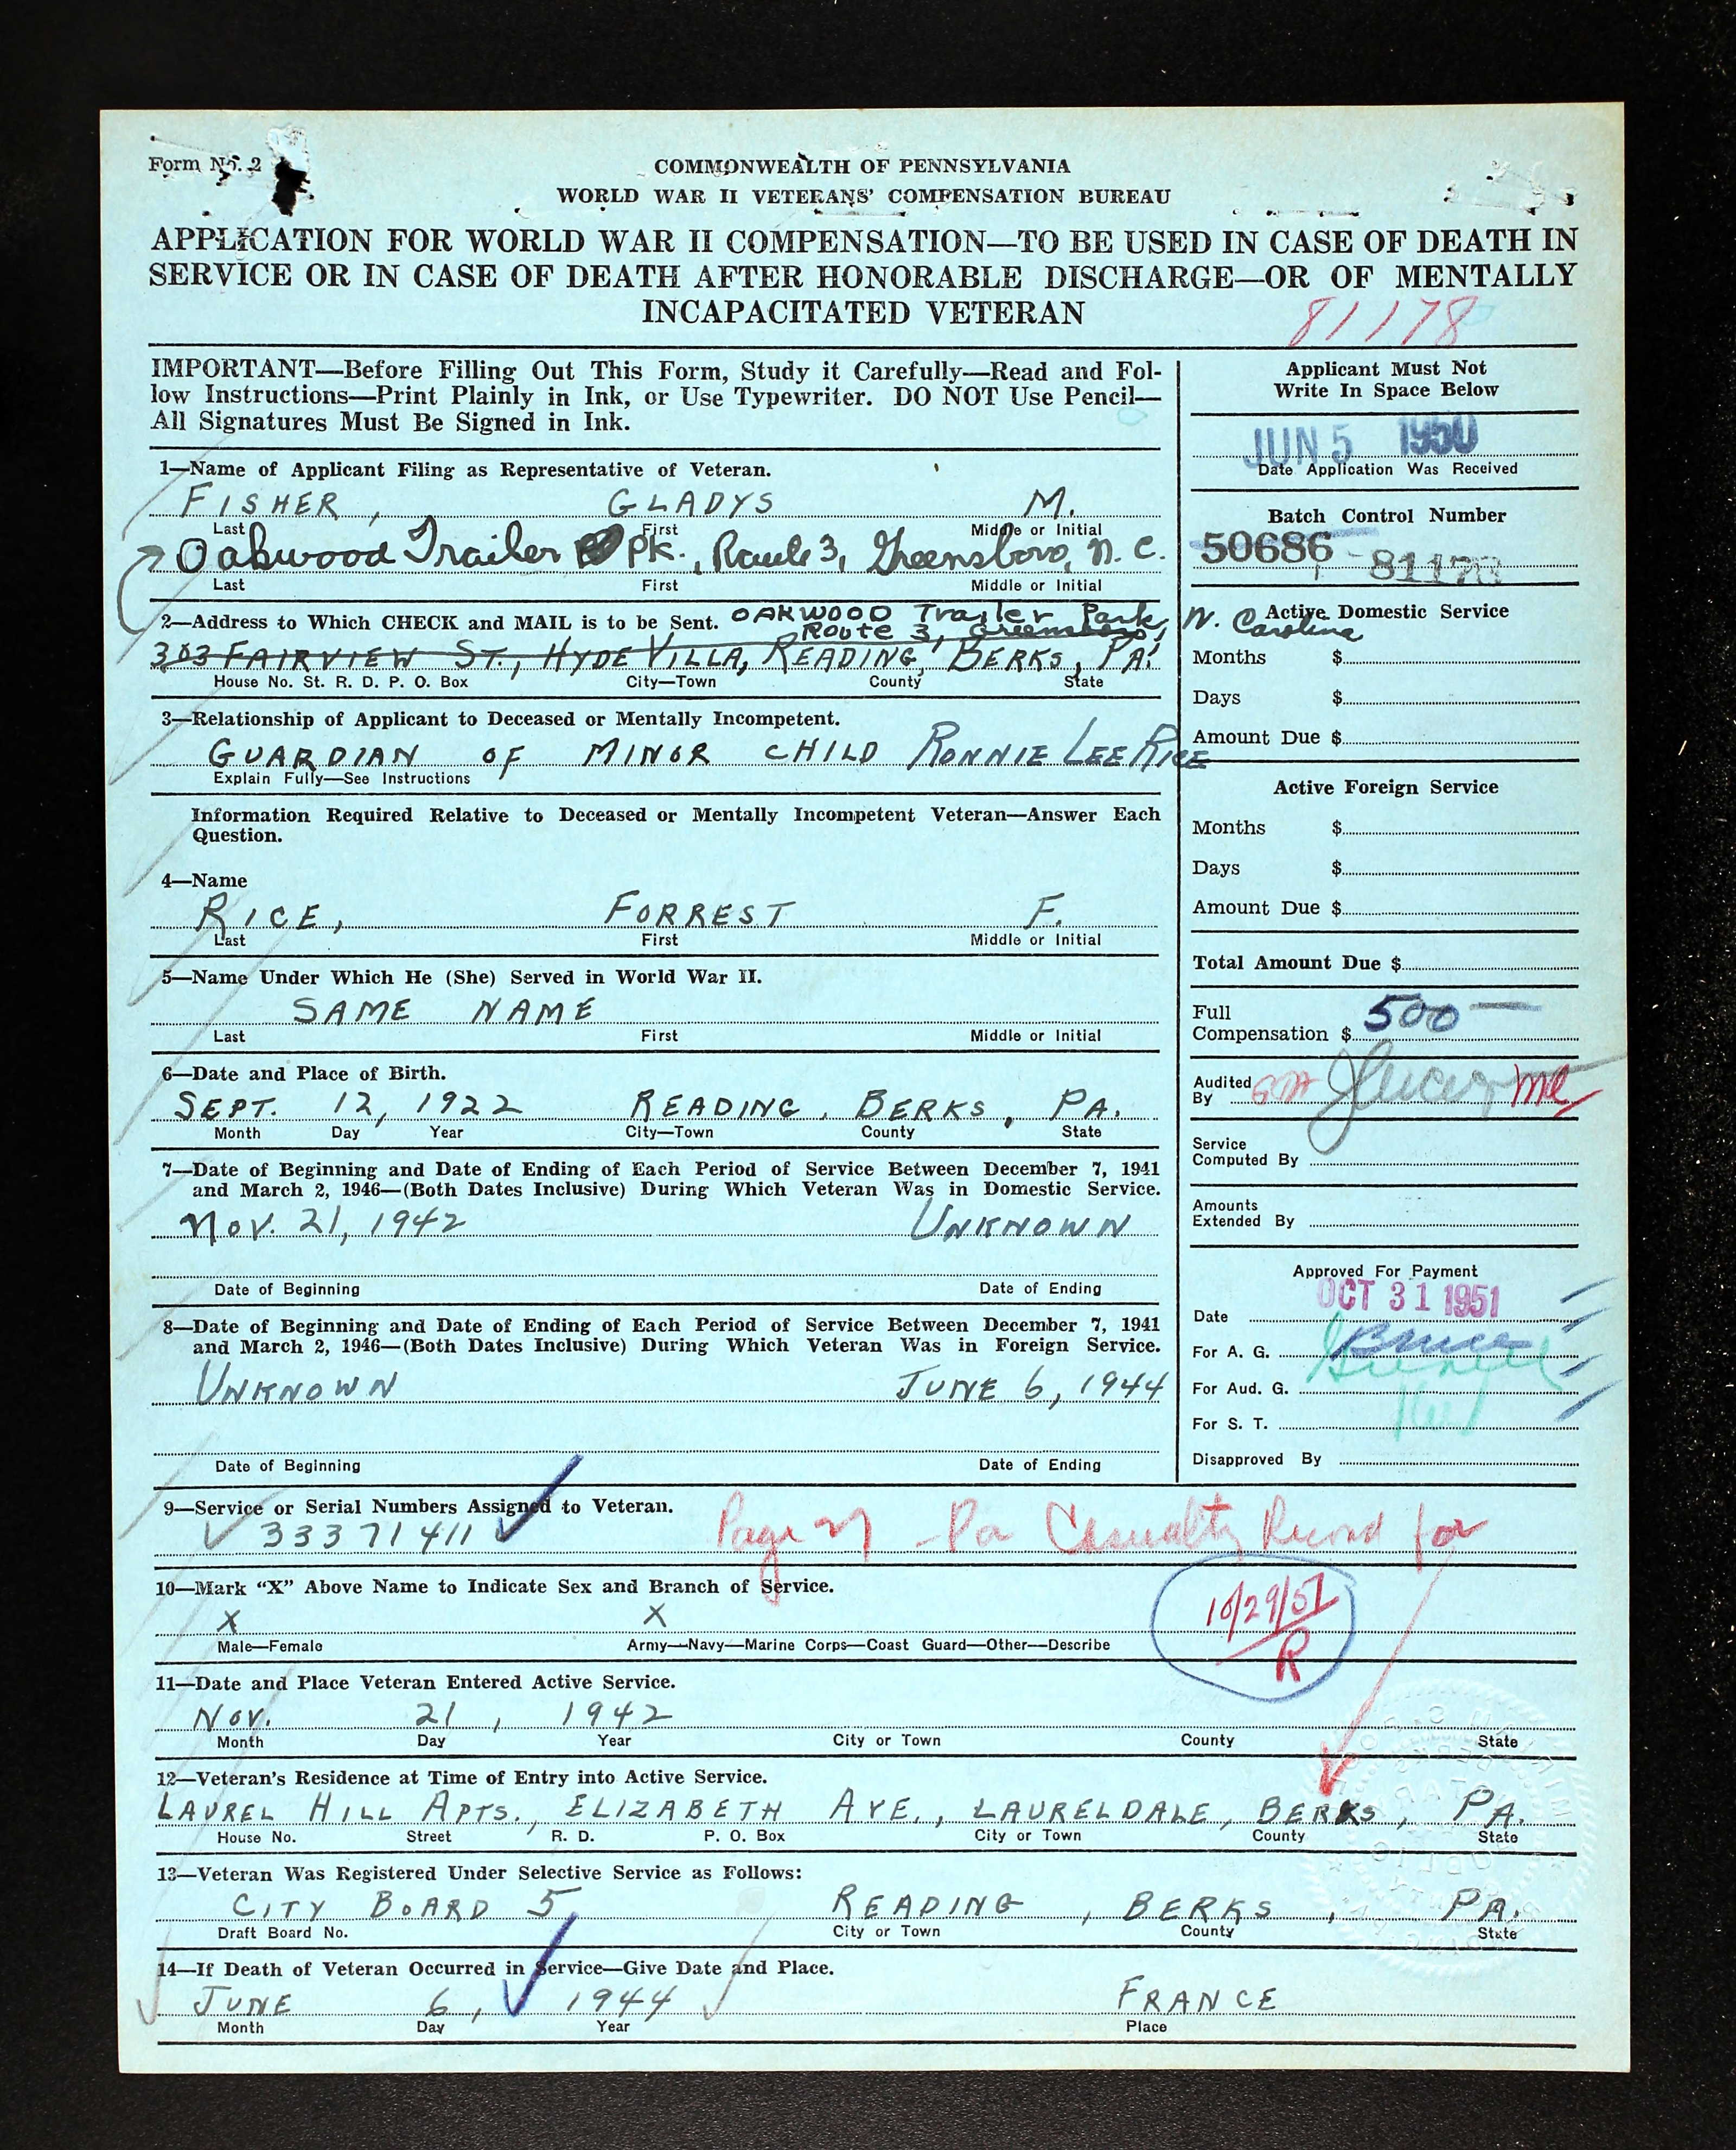

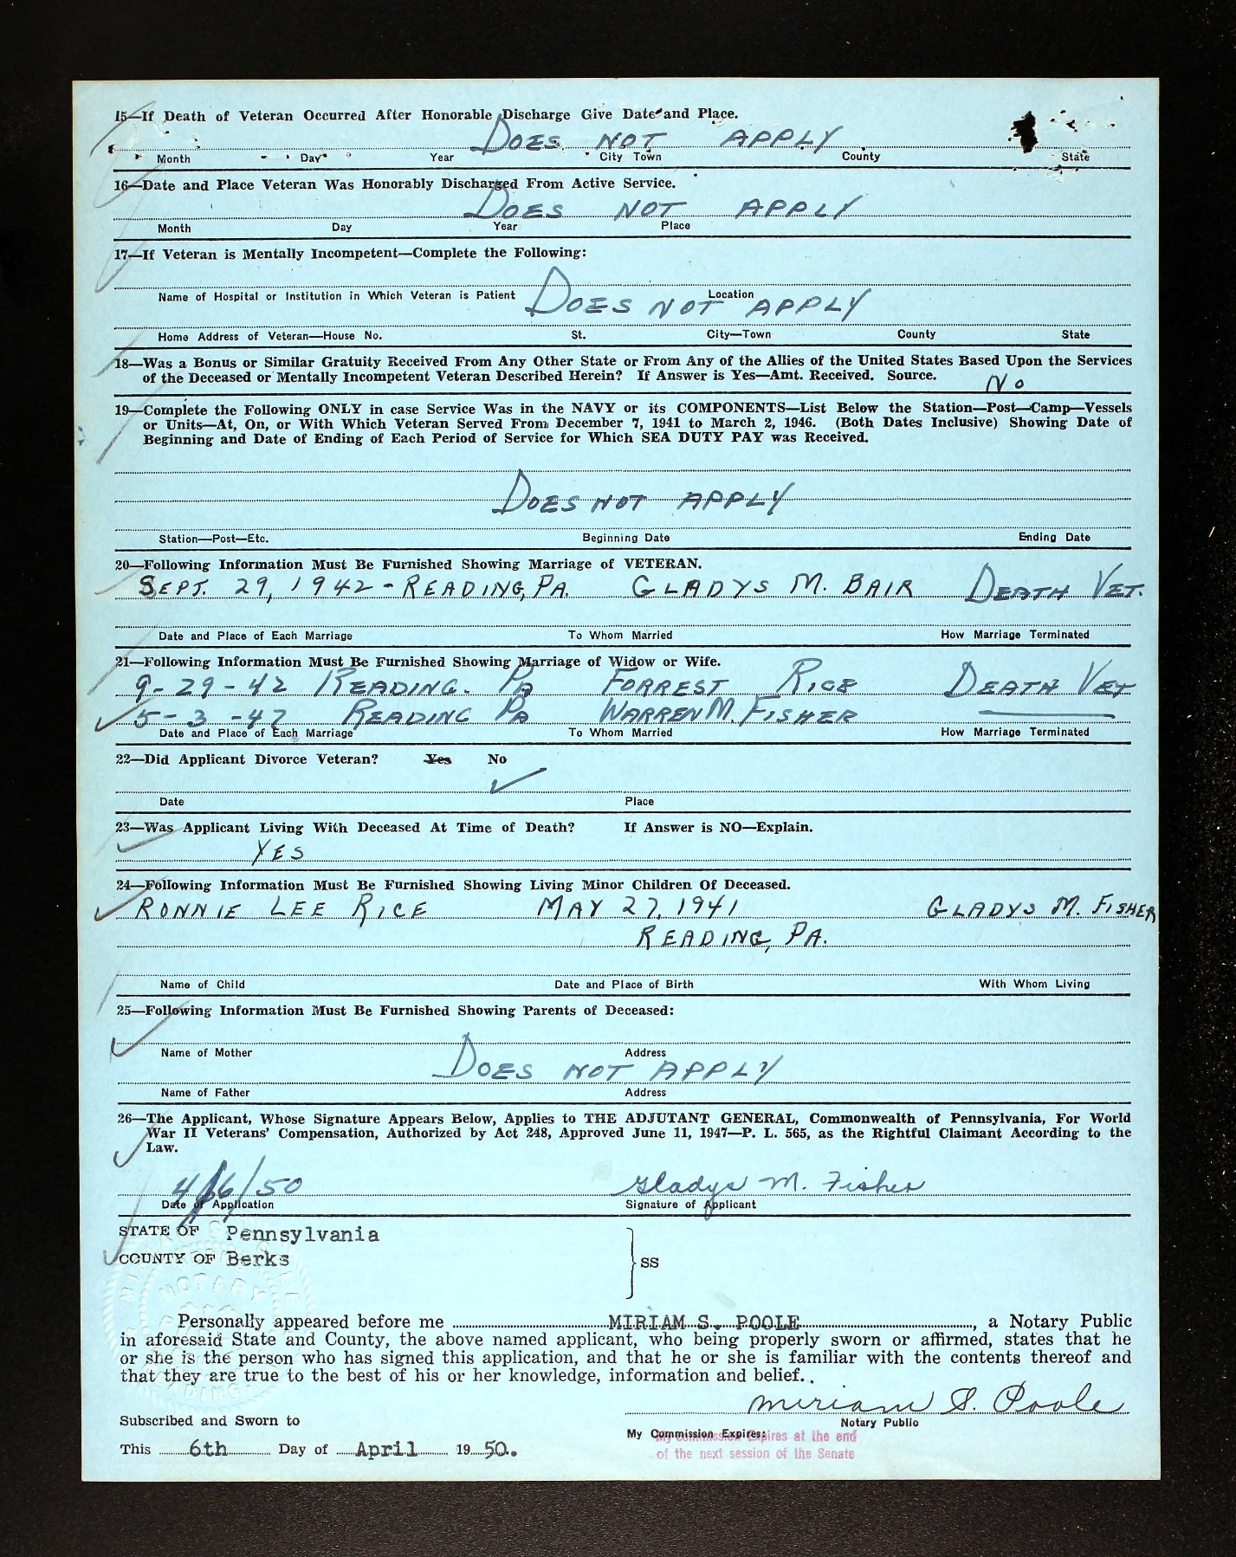

1930 Census
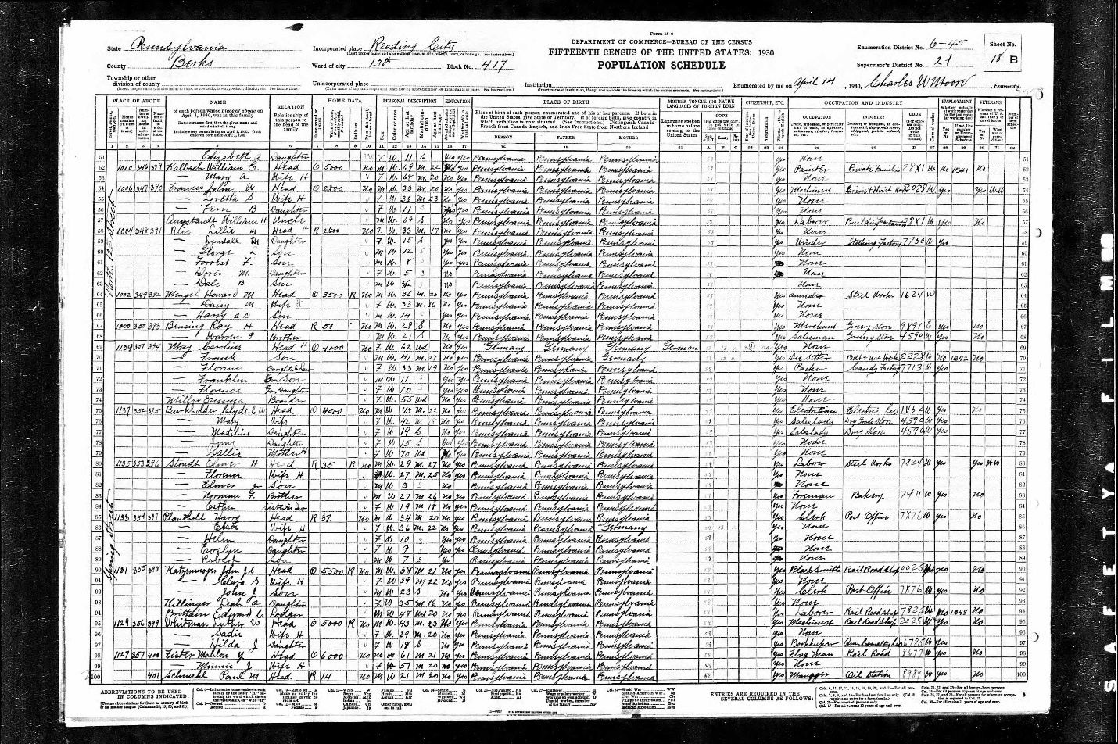

1940 Census
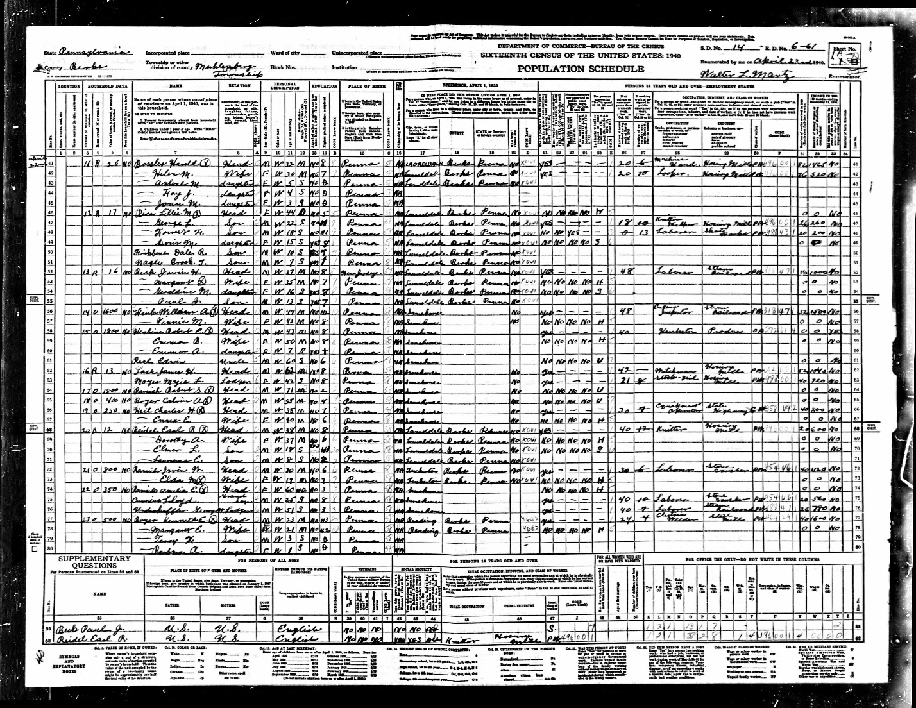

National Cemetery Interment Form
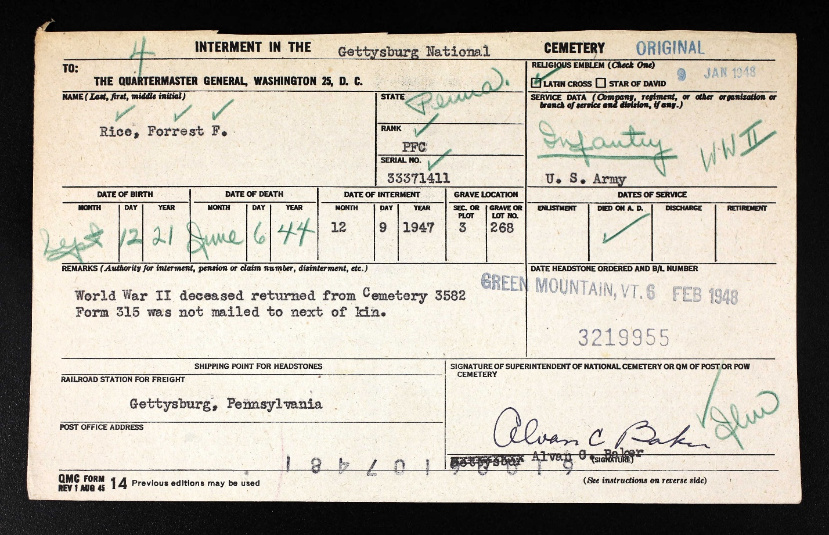

Gettysburg Compiler, December 6, 1947
